Cairo University  
Faculty of Computers and Information

**CS352**

**Software Engineering II**

**E _ Website**

Software Requirements Specifications

Team Leader

**Mohamed K Amer**

Month & Year

29 April 2017 at 23:59

Contents

Instructions [To be removed] 3

Your Restful API 3

Class diagram design 4

Daily scrum Meetings 5

Trello workspace screenshot 5

Github repository link 6

# 

# Team

|  |  |
| --- | --- |
| **ID** | Student Name |
| 20130194 | **Mohamed Khaled Mohamed Amer** |
| 20140071 | **Omnia Shawky Abdullah** |
| 20140118 | **Rasha Rabie El-Fauomy** |
| 20140209 | **Laila Barakat Mohamed** |

# Your Restful API

* **Add User**

|  |  |
| --- | --- |
| **Service Name** | **AddUser Service** |
| **Input Type** | **Get** |
| **Service URL** | **http://localhost:8000/AddUser** |
| **Parameters** | |  |  | | --- | --- | | **Name** | **User Name** | | **ID** | **User ID** | | **Password** | **User Password** | | **Type** | **User Type** | |
| **Example Request** | **POST**  **http://localhost:8000/AddUser** |
| **Example response** | **{"Name":Mohamed,"Status":"OK","ID":"20130194","Password":"55555","Type":"Teacher"}** |

* Login Service

|  |  |
| --- | --- |
| **Service Name** | **Login Service** |
| **Input Type** | **Get** |
| **Service URL** | **http://localhost:8000/CheckUser** |
| **Parameters** | |  |  | | --- | --- | | **Name** | **User Name** | | **Password** | **User Password** | |
| **Example Request** | **POST**  **http://localhost:8000/CheckUser** |
| **Example response** | **{"Name":"Mohamed", "Password":"555555"}** |

* **Add Game Service**

|  |  |
| --- | --- |
| **Service Name** | **AddGame Service** |
| **Input Type** | **POST** |
| **Service URL** | **http://localhost:8000/AddGame** |
| **Parameters** | |  |  | | --- | --- | | **ID** | **Game ID** | | **Name** | **Game Name** | | **Type** | **Game Type** | |
| **Example Request** | **POST**  **http://localhost:8000/AddGame** |
| **Example Response** | **http://localhost:8000/AddGame** |

* **Search Game Service**

|  |  |
| --- | --- |
| **Service Name** | **SearchGame Service** |
| **Input Type** | **POST** |
| **Service URL** | **http://localhost:8000/Search** |
| **Parameters** | |  |  | | --- | --- | | **Name** | **Game Name** | |
| **Example Request** | **POST**  **http://localhost:8000/Search** |
| **Example Response** | **http://localhost:8000/Search** |

* **Play Game Service**

|  |  |
| --- | --- |
| **Service Name** | * **Play Game Service** |
| **Input Type** | **POST** |
| **Service URL** | **http://localhost:8000/PlayGame** |
| **Parameters** | |  |  | | --- | --- | | **Name** | **Game Name** | |
| **Example request** | **POST**  **http://localhost:8000/PlayGame** |
| **Example response** | **http://localhost:8000/PlayGame** |

# Class diagram design

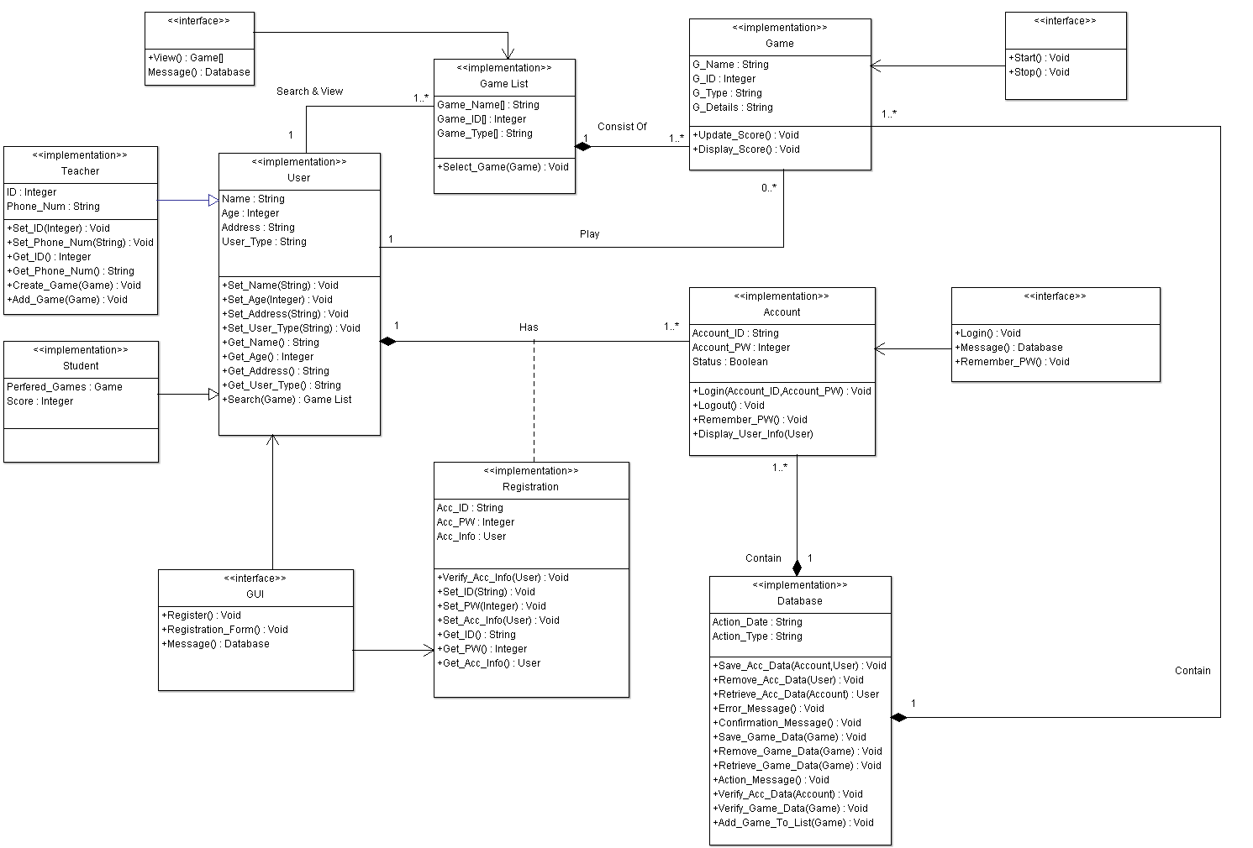

| **Class ID** | **Class Name** | **Description & Responsibility** |
| --- | --- | --- |
| **1** | **User** | **A parent class that contains all of attributes and methods that hold all information about Users that using our system.** |
| **2** | **Teacher** | **A child class extends from class user hold all attributes and special methods for user (teacher).** |
| **3** | **Student** | **A child class extends from class user hold all attributes and methods that user (student) can perform.** |
| **4** | **Registration** | **A class that represents all attributes and methods that belong to registration process.** |
| **5** | **Account** | **A class that holds all information about user’s accounts on the system also it is a strong part of any user on the system.** |
| **6** | **Game** | **A class holds all attributes and methods that identify each game on the system also help users to play any game.** |
| **7** | **Game List** | **A class that represents a collection of games each type belongs to a list on the database.** |
| **8** | **Database** | **This class holds action attributes and some methods that control the processes on the system classes, save data, retrieve data and delete data.** |
| **9** | **GUI** | **An interface class holds message methods and forms.** |

## II. Sequence diagrams

* **Registration (SD)**

### C:\Users\DesTrUcTioN\Desktop\New folder (3)\CS251-SE2016-TA. Omar Khaled-20130194-SRS-Template-v2.0-Mohamed Khaled Mohamed Amer\Sequence Diagram (Registration).gif

* **Add Game (SD)**

### C:\Users\DesTrUcTioN\Desktop\New folder (3)\CS251-SE2016-TA. Omar Khaled-20130194-SRS-Template-v2.0-Mohamed Khaled Mohamed Amer\Sequence Diagram (Add Game).gif

### Play Game (SD)

### C:\Users\DesTrUcTioN\Desktop\New folder (3)\CS251-SE2016-TA. Omar Khaled-20130194-SRS-Template-v2.0-Mohamed Khaled Mohamed Amer\Sequence Diagram (Play Game).gif

# 

# Trello workspace screenshot

# C:\Users\DesTrUcTioN\Desktop\Untitled.png

# Ownership Report

|  |  |
| --- | --- |
| ***Item*** | ***Owners*** |
| *All* | *Mohamed K Amer* |
| *All* | *Omnia Shawky Abdullah* |
| *All* | *Laila Barakat Mohamed* |
| *All* | *Raja Rabie El-Fauomy* |

Find us on Github.com

# Policy Regarding Plagiarism

**Students have collective ownership and responsibility of their project. Any violation of academic honesty will have severe consequences and punishment for ALL team members.**

1. تشجع الكلية على مناقشة الأفكار و تبادل المعلومات و مناقشات الطلاب حيث يعتبر هذا جوهريا لعملية تعليمية سليمة
2. ساعد زملاءك على قدر ما تستطيع و حل لهم مشاكلهم فى الكود و لكن تبادل الحلول غير مقبول و يعتبر غشا.
3. أى حل يتشابه مع أى حل آخر بدرجة تقطع بأنهما منقولان من نفس المصدر سيعتبر أن صاحبيهما قد قاما بالغش.
4. قد توجد على النت برامج مشابهة لما نكتبه هنا أى نسخ من على النت يعتبر غشا يحاسب عليه صاحبه.
5. إذا لم تكن متأكدا أن فعلا ما يعد غشا فلتسأل المعيد أو أستاذ المادة.
6. فى حالة ثبوت الغش سيأخذ الطالب سالب درجة المسألة ، و فى حالة تكرار الغش سيرسب الطالب فى المقرر.